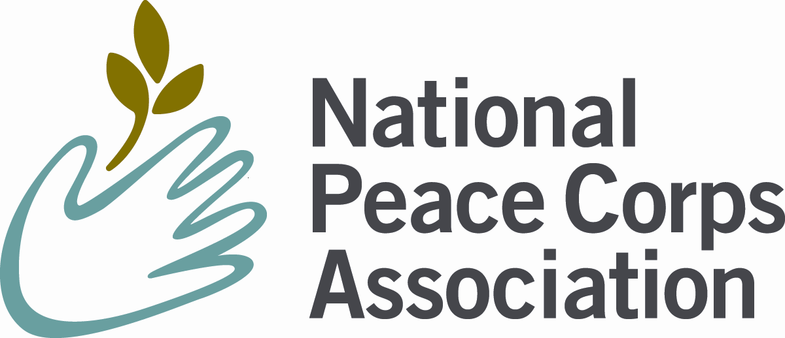
2013 Member Group Renewal

Who? NPCA Member Groups complete this process annually. This annual renewal process confirms that these groups exist, that they are active and that they are fiscally responsible. Groups first approved by the NPCA Board in 2012 are exempt from having to complete this renewal for 2013.

Why? NPCA promotes/markets our groups via multiple social media channels, enewsletters, websites and quarterly WorldView magazine; actively seeks out PCVs, RPCVs and former staff and makes their contact information available to groups; collects and processes group membership dues; and deposits funds directly in group accounts monthly. In return, NPCA member groups agree to promote/market the NPCA and NPCA membership; share information with NPCA and pass along any collected NPCA dues monthly.

We encourage all groups to be transparent in their governance and to post all relevant documents to their websites. For many groups, much of the information needed for this Group renewal is already posted. If so, simply check the boxes here and submit the report. If not, please attach copies of relevant documents.

What’s new? We recognize that the group renewal process can be quite time consuming for both member groups and NPCA. Given our interest in both a streamlined process and data needed for accountability to our members, our Board and our auditors, we periodically adjust the group renewal process. For 2013, we are asking for a slightly larger amount of information for the group renewal than in the past two years. It is our goal to make the 2014 renewal process considerably shorter than this year’s.

We also recognized that the ranges of groups’ sizes – used to determine renewal fees -- were too wide. We’ve created a “very small” member group size and adjusted the fees accordingly. We feel this more fairly distributes the fees.

To renew group membership in NPCA for 2013, fill in and submit the form below, the required attachments and the group renewal fee (based on the following chart):

Group size | By February 28, 2013 | by March 31, 2013 | by April 30, 2013
Very Small (less than 25 members) | $20 | $25 | $50
Small (26-100 members) | $40 | $50 | $100
Medium (101-250 members) | $80 | $100 | $200
Large (250 or more members) | $320 | $400 | $500

Please electronically submit to groups@peacecorpsconnect.org.

Or, if necessary, you may submit via postal mail to:
NPCA Member Group Renewal
1900 L Street NW, Suite 610
Washington, DC 20036
Attn: Group Renewal
Questions?
Contact Emily Bello at emily@peacecorpsconnect.org.

2013 NPCA Member Group Renewal – Group Activities Summary
Group Contact Information
Member Group Name: Friends of Morocco
Member Group Mailing Address: PO Box 2579
Washington, DC 20013-2579
Group Links for NPCA Member Group webpage:
Member Group E-Mail: timresch@gmail.com
Member Group Website: http://friendsofmorocco.org

Communications – check each tool you use to communicate with your members

X NPCA’s Social Network
X Facebook
LinkedIn
Twitter
X E-newsletter or listserv
Print newsletter
X Other (please specify): Geographic specialized e-mailings
Group Leadership (add more as appropriate)
Position: President Name: Tim Resch
Position: Corporate representative (DC resident)Name: Tom Birch
Position: Board of Directors Name: Ruth Ann Skaff
Position: Board of Directors Name: Jerry Bookin-Weiner
Position: Board of Directors Name: Hassan Samrhouni

Membership Demographics
Please indicate below an estimate for the number of your members (and those on your mailing list) that fit into each category:
Group Member Type  Country of Service | Number involved in the group
Total Members Names on List | 3970 of which 3612 RPCV
Recently Returned RPCVs (within the last 5 years)2008 to 2012 | 110
Pioneer RPCVs (served in the 1960s and 1970s)1962 to 1970 | 1422
Host Country Nationals | 101
Non-RPCVs = Academics, PC staff, other USG and tourists | 220

Required elements (which must be checked here OR sent as email attachments):
X We have communicated by e-mail or mail with our members since September 2012 and NPCA already has copies.
X A description of group activities is posted on our website. (Link: http://friendsofmorocco.org/events.htm and http://www.meetup.com/friendsofmorocco)

X A financial report from 2012 is posted on our website. (Link: http://friendsofmorocco.org/Docs/FOM2012financialstatement.doc )

Additional Required Questions

- Please mark all the below documentation your group possesses
X By-laws X Federal 501(c)3 status
X Articles of Incorporation □ State tax exemption
□ Constitution □ Other ______________

- What does your group consider its main form for connecting, informing and/or engaging members online? (Website, NPCA Social Network, Facebook groups, YouTube and email)

- Does your group accept membership dues on behalf of NPCA? YES

- Please verify these criteria for NPCA Member Group affiliation:
X We list our membership in the National Peace Corps Association on our website
(link: http://friendsofmorocco.org/index.htm
X We link to the NPCA (http://www.peacecorpsconnect.org) on our website
(link: http://friendsofmorocco.org/index.htm
X We promote the activities of the NPCA in our communications and/or on our website.

- Will your group host a meeting, presentation, reunion or other event at Peace Corps Connect – Boston on June 28, 2013? YES

If so, please give a brief description of what you are planning:
Dinner either Thursday or Friday evening

Please submit the 2013 NPCA Member Group Renewal as outlined on the first page. With your submission, you agree to the member group terms as highlighted at the beginning of this document. This completes the 2013 NPCA Member Group Renewal!

Submitted by: Tim Resch
Office held: President Date: April 29, 2013

